TfL “What-If” Simulation Database Design Document
- Overview
This database models the London Underground network as a graph to support routing, disruption simulation and shortest-path analysis. Each station is represented as a node and connections between stations are represented as relationships.
A Neo4j graph database was chosen over a relational database because:
- The underground network is inherently graph shaped.
- Shortest-path and rerouting queries are more efficient and expressive.
- Relationships (connections) are first-class data, not join tables.
The database is used by the application to:
- Find the shortest route between two stations.
- Recalculate routes when stations or lines are disrupted.
- Perform future network analysis and simulations.

- Conceptual Model
At a high level, the network consists of:
- Station nodes represent underground stations.
- CONNECTS_TO relationships represents direct track connections between stations
(Station) –[CONNECTS_TO]-> (Station)
Each connection stores metadata such as the line name and the distance between stations.

- Node Definitions
  - Station Node
Description: Represents a single London Underground station.
Property | Type | Description
id | String | Unique TfL station identifier
name | String | Human‑readable station name
lat | Float | Latitude coordinate
lon | Float | Longitude coordinate
- Relationship Definitions
  - CONNECTS_TO Relationship
Description: Represents a direct connection between two consecutive stations on a tube line.
Although the underground is bidirectional, connections are stored as directed relationships to support traversal algorithms. Bidirectional travel is achieved by creating relationships in both directions where required.
Property | Type | Description
line | String | Line Identifier (e.g. victoria)
lineName | String | Human‑readable line name
distance | Float | Estimated distance in meters

- Constraints and Data Integrity
  - Station ID Uniqueness Constraint
CREATE CONSTRAINT station_id_unique IF NOT EXISTS
FOR(s:Station)
REQUIRE s.id IS UNIQUE;
Purpose:
- Prevents duplicate station nodes.
- Ensures consistent merging when importing data from multiple lines.
- Improves lookup performance by station ID.
This constraint guarantees that each real-world station exists exactly once in the graph.

- Distance Calculation
Distances between stations are calculated using the Haversine formula, which estimates the straight-line distance between two points on the Earth’s surface based on latitude and longitude.
Why this approach was chosen:
- TfL does not provide actual track lengths via the public API.
- Provides consistent edge weights for shortest-path algorithms.
- Computationally simple and reliable.
Limitations:
- Does not represent true tunnel or track length.
- Does not account for curvature of tracks or elevation.
Despite these limitations, haversine distance is sufficient for route comparison and disruption rerouting.

- Data Ingestion Process
Data is sourced from the TfL Unified API, specifically:
- /Line/{id}/Route/Sequence/all
This endpoint provides ordered station sequences for each tube line. From this data:
- Stations are extracted and stored as nodes.
- Consecutive stations are connected via CONNECTS_TO relationships.
- Distances are calculated at ingestion time.
Duplicate stations across lines are handled using the unique station ID constraint.

- Example Queries
  - Find a Station by Name
MATCH (s:Station {name: “Oxford Circus Underground Station”})
RETURN s;
Returns the Station node of Oxford Circus.

  - Find Shortest Path between Two Stations
MATCH (start:Station {name: "King's Cross St. Pancras Underground Station"})
MATCH (end:Station {name: "Waterloo Underground Station"})
CALL apoc.algo.dijkstra(start, end, 'CONNECTS_TO>', 'distance')
YIELD path, weight
RETURN path, weight;
This query finds the shortest route based on distance rather than number of stops:
- path: Neo4j path object containing nodes and relationships
- weight: sum of distance along the path.
When executed this query will display a graph showing the route that the path takes being:
- King’s Cross -> Russell Square -> Holborn -> Covent Garden -> Leicester Square -> Charing Cross -> Embankment -> Waterloo
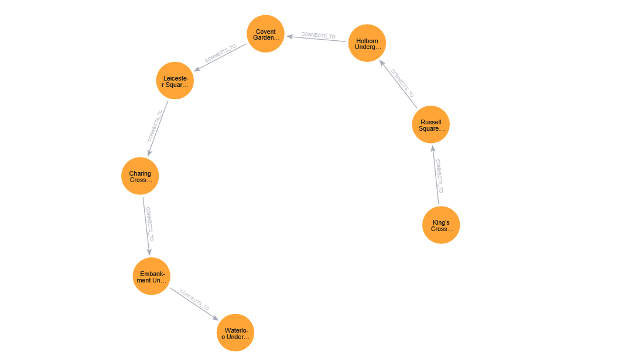
Figure 1 - Neo4j Graph of Dijkstra algorithm being performed from King's Cross to Waterloo station.

  - Find all stations from a specific line
MATCH (a:Station)-[r {line:"bakerloo"}]->(b:Station)
RETURN a, r, b
Returns all stations within a line, in this example it gets all the stations with the Bakerloo line.

- Limitations
- Distances are estimated, not exact track lengths.
- Travel time and service frequency are not currently modelled.
- Real-time disruption data is not yet integrated.

- Summary
This Neo4j database provides a clean, scalable representation of the London Underground network. By modelling stations and connections as a graph, it enables efficient shortest-path calculations and supports future expansion into more advanced transport simulations.

